**PRACTICE PROBLEM IN CLASS –02.08.2024**

1.write a java program to display the second array list with specify element in the list

import java.util.ArrayList;

public class ArrayListExample {

public static void main(String[] args) {

ArrayList<String> firstList = new ArrayList<>();

firstList.add("Apple");

firstList.add("Banana");

firstList.add("Cherry");

ArrayList<String> secondList = new ArrayList<>();

secondList.add("Dog");

secondList.add("Elephant");

secondList.add("Frog");

int index = 1;

if (index >= 0 && index < secondList.size()) {

String element = secondList.get(index);

System.out.println("Element at index " + index + " in the second ArrayList: " + element);

} else {

System.out.println("Index " + index + " is out of bounds for the second ArrayList.");

       }

    }

}

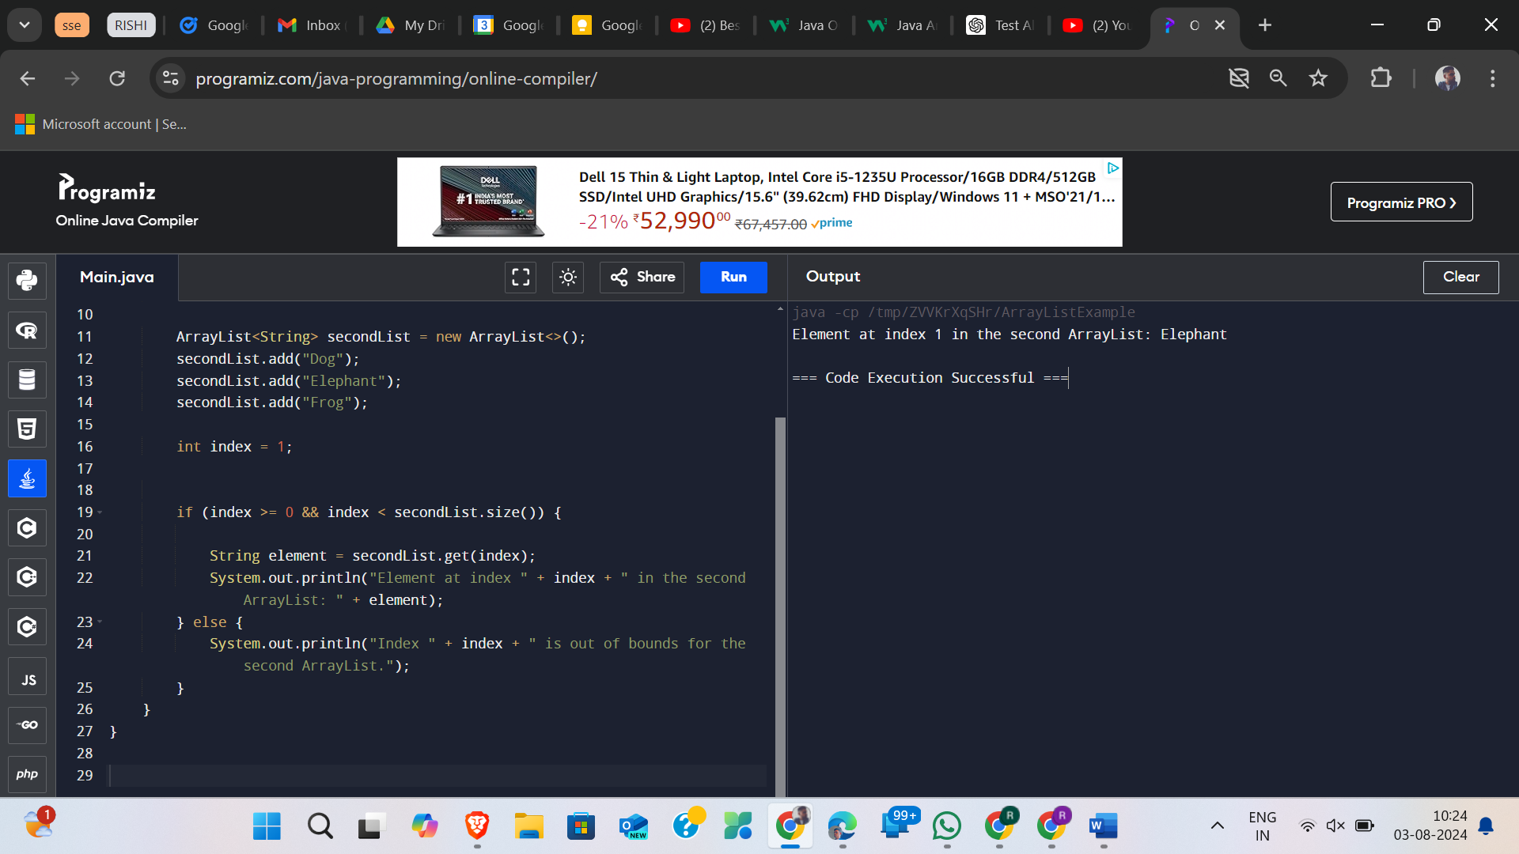

2. write a java program in the array list add some colours and printout the collections

import java.util.ArrayList;

public class ColorCollection {

public static void main(String[] args) {

// Create an ArrayList to store colors

ArrayList<String> colors = new ArrayList<>();

// Add some colors to the ArrayList

colors.add("Red");

colors.add("Blue");

colors.add("Green");

colors.add("Yellow");

colors.add("Purple");

// Print out the collection of colors

System.out.println("Color Collection:");

for (String color : colors) {

System.out.println(color);

}

}

}

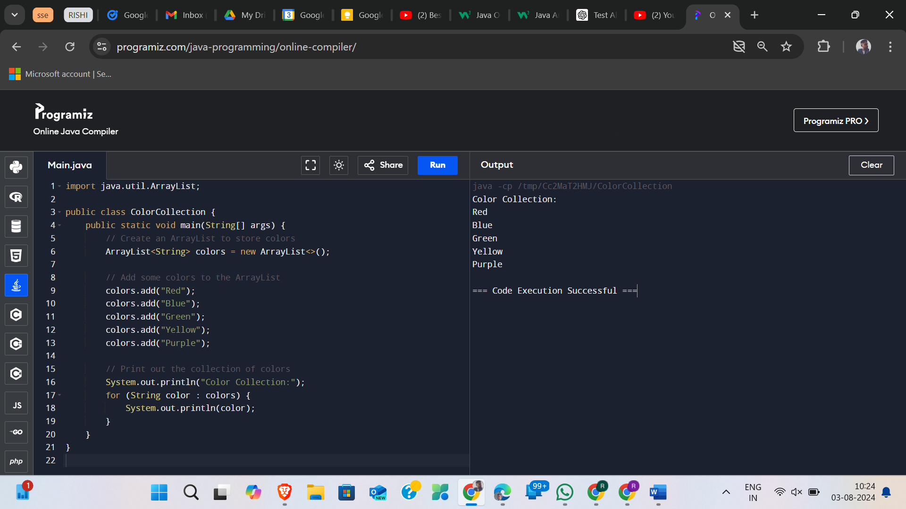

3.reverse the elemennt in the array list

import java.util.ArrayList;

import java.util.Collections;

public class ColorCollection {

public static void main(String[] args) {

// Create an ArrayList to store colors

ArrayList<String> colors = new ArrayList<>();

colors.add("Red");

colors.add("Blue");

colors.add("Green");

colors.add("Yellow");

colors.add("Purple");

System.out.println("Original Color Collection:");

for (String color : colors) {

System.out.println(color);

}

Collections.reverse(colors);

System.out.println("\nReversed Color Collection:");

for (String color : colors) {

System.out.println(color);

}

}

}

